Tab 1

### Contract Processing Steps *(Implementation/Success to fill)*

For contracts that look like the following, follow the steps below to process. Be sure to scroll down to the order form to view the information since it typically does not live on the first page.

Contracts will typically include the following. [Garage processing example](https://garage.tabsplatform.com/prod/contracts/4f88dac4-e4fd-4d23-97f7-cc7cd6d176de/terms/revenue)

* Included Seats
* Additional Seats
* Per Active Employee Per Month

#### IMAGE 1.1

##### IMAGE 1.2

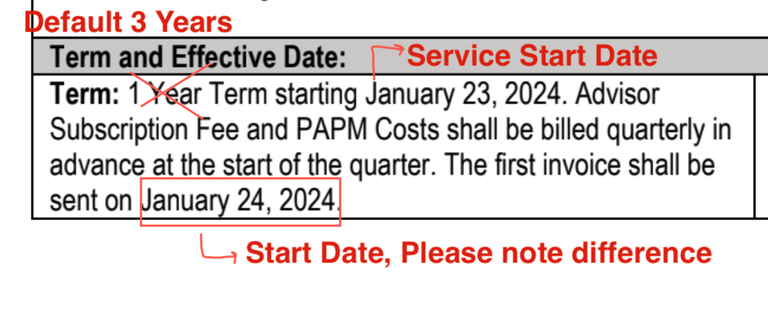

Steps to process

*You will have to create Different Revenue Schedules for Each type of charge*

##### **Follow Steps below for the included Seats with Pricing REV SCHEDULE #1 (example in Garage)**

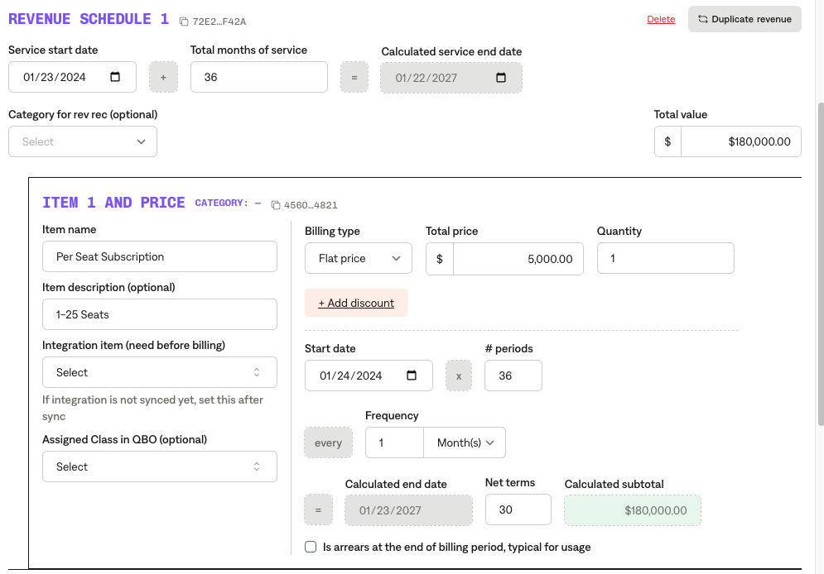  
**Service Start Date:** Will be Term start date(see screenshot below)

**Months of Service:** Default 36 months (3 years)

**Item Name:** Refer to Image 1.1**,** contract.  
**Item Description:** Refer to Image 1.1 **Integration Item:** [**TIFIN Netsuite Integration Items**](https://docs.google.com/spreadsheets/d/1fAQ1rHf_buFcowql7ONgAj6gY01wd3u6nwM4ZAUxqhY/edit?gid=515133391#gid=515133391) **Billing type:** Flat

**Total Price:** Refer to Image 1.1 to find where it lives on contract  **Quantity:** 1 **Start Date:** Same as service start date refer to Image 1.2

**Periods:** default to 36 if monthly

**Frequency:** Monthly for Per Seat Subscription unless otherwise stated

**Net Terms:** Default 30

###### Follow Steps below for the Additional Seats with Pricing REV SCHEDULE #2 (example in Garage)

**Service Start Date:** Will be Term start date(see screenshot below)

**Months of Service:** Default 36 months (3 years)

**Item Name:** Additional Seat or Other naming convention shared  
**Item Description:** Blank **Integration Item:** [**TIFIN Netsuite Integration Items**](https://docs.google.com/spreadsheets/d/1fAQ1rHf_buFcowql7ONgAj6gY01wd3u6nwM4ZAUxqhY/edit?gid=515133391#gid=515133391) **Billing type:** UNIT

**Total Price:** Price stated in contract **Event to track:** Additional Seat **Start Date:** Same as service start date refer to Image 1.2

**Periods:** default to 36 if monthly

**Frequency:** Monthly for Per Seat Subscription unless otherwise stated

**Net Terms:** Default 30

###### Follow Steps below for the Per Active Employee Per Month Pricing REV SCHEDULE #3 (example in Garage)

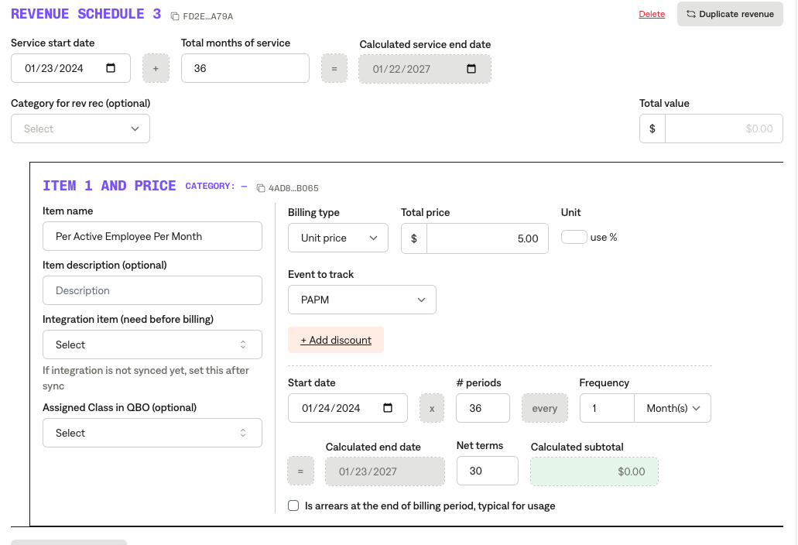

**Service Start Date:** Will be Term start date

**Months of Service:** Default 36 months

**Item Name:** Per Active Employee Per Month or Other naming convention shared  
**Item Description:** Blank **Integration Item:** [**TIFIN Netsuite Integration Items**](https://docs.google.com/spreadsheets/d/1fAQ1rHf_buFcowql7ONgAj6gY01wd3u6nwM4ZAUxqhY/edit?gid=515133391#gid=515133391) **Billing type:** UNIT

**Total Price:** Price stated in the contract **Event to track:** PAPM **Start Date:** Same as service start date refer to Image 1.2

**Periods:** default to 36 if monthly

**Frequency:** Monthly for Per Seat Subscription unless otherwise stated

**Net Terms:** Default 30

1. Anything to ignore in contracts?
   1. Anything that shows “*waived”*
2. Specifics processing things the merchant has requested that may differ by contract (e.g. always back-date invoice date to final day of the month)
3. Default Service Term
   1. Default 3 Years
4. Default Net Payment Terms
   1. Default 30
5. Default Billing Frequency
   1. If None Listed, Ops Default is Monthly
6. How do we handle taxes as a line item?
   1. If None Listed, Ops Default is every tax line item becomes a BT

### Events Processing (if necessary) *(Implementation/Success to fill)*

* Any important information on events billing

Integration Items Processing (if necessary)  
*(Implementation/Success to fill)*

* What are the instructions for assigning integration items? [TIFIN Netsuite Integration Items](https://docs.google.com/spreadsheets/d/1fAQ1rHf_buFcowql7ONgAj6gY01wd3u6nwM4ZAUxqhY/edit?gid=515133391#gid=515133391)
* Example: All Statsig integrations items should be labeled as “Sales”
* Example: All “Pinata” integration items should be labeled as “Software Subscription Bundle” unless otherwise noted by Merchant